Volunteer Recruitment Kit 2024/25

Dear Tutors and Team Members,

Elementary students eagerly await volunteer tutors for the 2024/25 school year! Heart Math Tutoring (“HMT or Heart”) has partnered with 23 schools in Charlotte NC, four schools in Charleston SC, and two schools in Winston-Salem NC to support 1,500 students in developing foundational math skills and confidence. Please use the ideas below to help us find volunteers willing to spend 1 hour per week with students on math and mentorship.

As a reminder, HMT provides tutor training, easy-to-follow lesson plans, and program support to volunteers. Most tutoring will take place in-person at elementary schools across Charlotte, Charleston, and Winston-Salem, while tutoring at select school sites will be fully virtual. Volunteers commit to tutoring for 30 minutes or one hour per week.

Ways to Support Recruitment Efforts

- Sign up to tutor next year at www.heartmathtutoring.org/become-a-volunteer/.
- Share about your HMT experience with others.
- Recruit a friend, family member, or colleague to tutor.
- Share flyers through emails to colleagues, neighbors (e.g., neighborhood association email blast), those you fellowship with at your respective places of worship, or civic groups. Email volunteer@heartmathtutoring.org for unique email templates or printable flyers.
- Send volunteer recruitment ideas (individuals, organizations) or funding ideas to HMT staff at volunteer@heartmathtutoring.org.
- Invite HMT to make a 5 – 20-minute virtual or in-person presentation to your workplace, place of worship, or community organizations.
- Follow and tag HMT on social media and use hashtags #YourAdditionCanMakeADifference and #VolunteerWithHeart. Direct Message us for shareable content or email volunteer@heartmathtutoring.org for further instructions. (Find us on Instagram: @heartmathtutoring Twitter: @hearttutoring Facebook & LinkedIn: Heart Math Tutoring)
- Add Heart Math Tutoring as a volunteer activity on your LinkedIn profile: Click “Add Profile Section,” “Additional,” and select “Add Volunteer Experience.” When you type “Heart Math Tutoring,” LinkedIn will find our Company Page.
- Share the example tutoring games found here: https://heartmathtutoring.org/families/

See templates on the pages that follow.

Thank you for helping to ensure that all students build the strong foundation in math and enthusiasm for academics needed for long-term success!

With Gratitude,
The Heart Math Tutoring Team
Friend/Colleague Email Template

Hi [Name],

I hope you’re doing well! I am a volunteer with Heart Math Tutoring, a non-profit that recruits volunteers to serve as tutors for elementary school students across [indicate your region here]. We are currently recruiting volunteer tutors for students during the 2024/25 school year.

[Explain why you’re emailing, if there’s a reason, e.g., I know you have a passion for education, and this is a great way to make a big difference in a child’s life with a small amount of time.]

Volunteers have the option to work with students [Charlotte – either virtually or in-person] for 1 hour per week starting in fall 2024. Heart Math Tutoring provides an easy-to-follow curriculum with interactive activities and games, and a Program Coordinator onsite to support students and tutors. Volunteers say that it’s the highlight of their week!

[Give personal details about your own experience, e.g. I volunteer on Tuesdays from 7:45-8:45 for Montclaire Elementary, and the process is very easy. I work with a 3rd grade boy who is precious!]

Is this volunteer opportunity something you’re interested in?

If you have an hour to share each week then I highly encourage you to sign-up here: www.heartmathtutoring.org/become-a-volunteer/ or reach out to volunteer@heartmathtutoring.org with any questions.

Many thanks,
[Name]

Partner Organization Email Template
Hi [Name],

I hope you are well! I am a volunteer with Heart Math Tutoring, a non-profit that recruits and supports volunteers to serve as math tutors for elementary school students across [indicate your region here]. We are currently looking for volunteers to support students below grade level in math for the 2024/25 school year.

[Explain why you’re emailing, if there’s a reason, e.g. I know your organization values volunteerism and community involvement, or I know you have been looking for ways to support the community, or I know you have been looking for ways to continue supporting students at [School Name] etc.]

Volunteers work with students for 30 minutes or one hour each week. Heart provides a proven curriculum with fun interactive games, as well as training and support from a Program Coordinator. [Charlotte – Tutors have the option to work with students either virtually or in-person starting in fall 2024.] Volunteers say that it’s the highlight of their week!

Is this something that would interest your employees/congregation/group? If so, I’ll connect you to someone on Heart Math Tutoring’s team.

Best Regards,
[Name]

Newsletter Blurb

Elementary students in [region] eagerly await volunteer tutors for the 2024/25 school year! Many of [region]’s elementary school students are performing below grade level in math and individualized support is needed now more than ever. Volunteering with Heart Math Tutoring is a fun, effective way to make a difference by working one-on-one with students each week. Volunteers say that it’s the highlight of their week! With the support of a Program Coordinator, volunteers use an easy-to-follow, proven curriculum featuring interactive activities and games. Volunteers commit to tutoring for 30 minutes or one hour per week, [Charlotte – either in-person or virtually, Charleston – at one of four schools in Charleston, Winston-Salem – at one of two schools in Winston-Salem]. Sign up today and choose the school and time that works for you at www.heartmathtutoring.org/become-a-volunteer/.

Text Message Template

Hi! Elementary students in [region] eagerly await volunteer tutors for the 2024/25 school year! Heart Math Tutoring is pairing volunteers with students for the upcoming school year. This is an incredible experience that directly impacts the life of an elementary student with just 1 hour/week. [Give personal details about your own experience, e.g. I volunteer on Tuesdays from 7:45-8:45 for Montclaire Elementary, and the process is very easy. I work with a 3rd grade boy who is precious!]! See schools and time options at www.heartmathtutoring.org/become-a-volunteer/. Would you be interested in spending 1 hour per week with a student?

Media Pitch Template

Hi [Name],

I hope you are well! I am a volunteer with Heart Math Tutoring (www.heartmathtutoring.org), a non-profit that recruits and supports volunteers to serve as math tutors for elementary school students across Charlotte, Charleston, and Winston-Salem. Many elementary school students are performing below grade level in math and individualized support is needed now more than ever. We are currently recruiting tutors for [Charlotte – 1,200 students in Charlotte, Charleston – 170 students in Charleston, Winson Salem – 100 students in Winston-Salem] who are below grade level in math.

[Explain why you’re emailing, if there’s a reason, e.g., I know that your show/magazine/blog has a large audience, and I think this is something that your viewers/readers/subscribers would be interested in.]

Heart Math Tutoring provides training, easy-to-follow lesson plans, and program support to volunteers. Volunteers say that it’s the highlight of their week! The majority of tutoring will take place in-person at elementary schools across Charlotte, Charleston, and Winston-Salem, while tutoring at select school sites in Charlotte will be fully virtual. Volunteers commit to tutoring for 30 minutes or one hour per week.

Is this something you would be interested in publicizing with your audiences? If so, I’ll connect you to a contact at Heart Math Tutoring.

Best Regards,
[Name]

Share on Social Media

Click on or visit one of the links to images below –
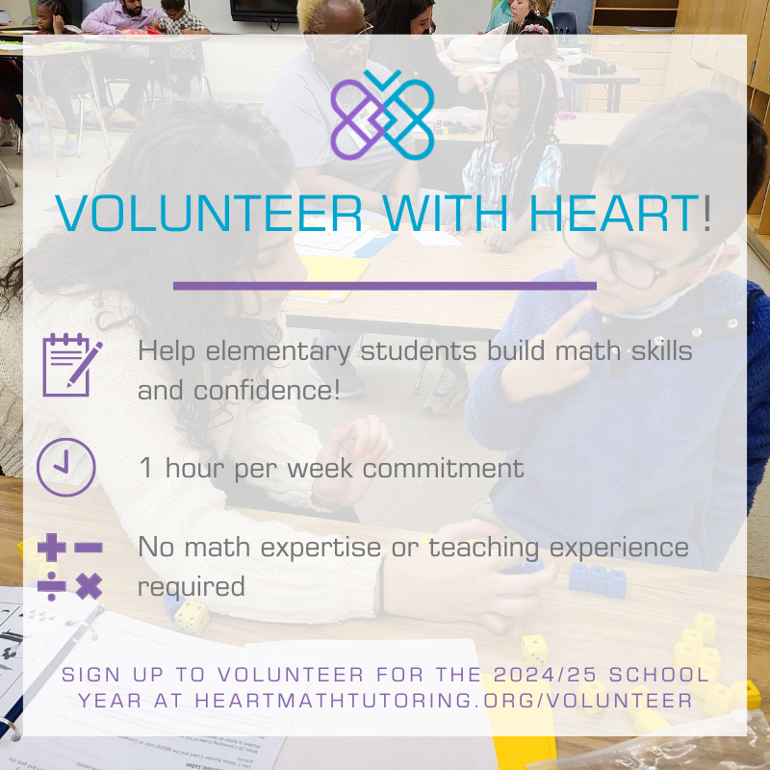
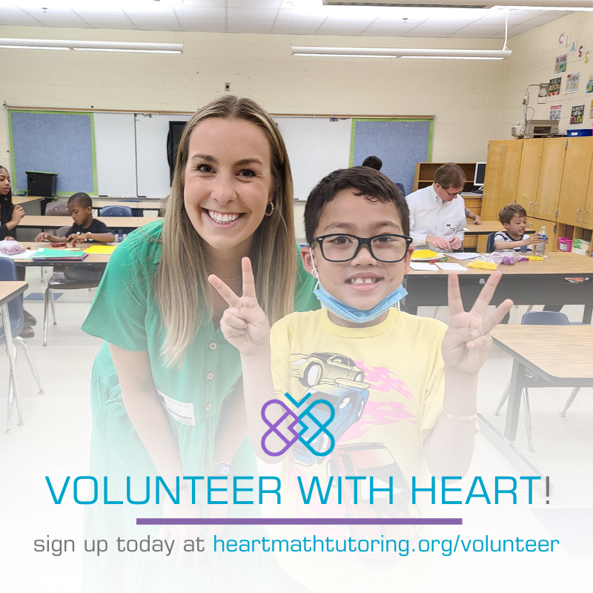
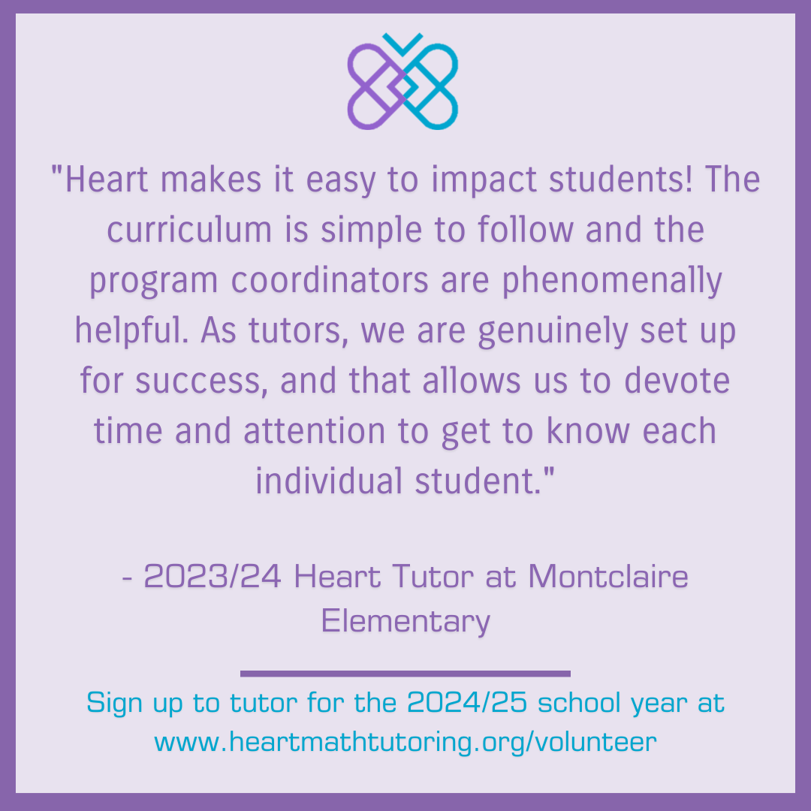
Facebook/LinkedIn –
- Calling all [region] volunteers! @heartmathtutoring is recruiting volunteers to support [Charlotte – 1200, Charleston – 170, Winston Salem – 100] elementary school students! Find a location and time (including virtual options) that work for you and sign up today! heartmathtutoring.org/become-a-volunteer #YourAdditionMakesADifference #VolunteerWithHeart
- Make an impact in a student’s life with just 1 hour a week! @heartmathtutoring is recruiting volunteers to support [Charlotte – 1200, Charleston – 170, Winston Salem – 100] elementary school students in [region]! Pick a time that works for you and sign up today! heartmathtutoring.org/become-a-volunteer #YourAdditionMakesADifference and #VolunteerWithHeart
- Join me and @heartmathtutoring this year in supporting students at [School Name]! You can make a big impact with just an hour a week. Learn more and get signed up at heartmathtutoring.org/become-a-volunteer #YourAdditionMakesADifference and #VolunteerWithHeart

Twitter –
- Make an impact in a student’s life with just 1 hr/week! Sign up today at heartmathtutoring.org/become-a-volunteer #YourAdditionMakesADifference
- 1 hour of your week = big impact for an elementary school student! Sign up to tutor with @hearttutoring at heartmathtutoring.org

Instagram –
- Make an impact in a student’s life with just 1 hour a week! @heartmathtutoring is recruiting volunteers to support [Charlotte – 1200, Charleston – 170, Winston Salem – 100] elementary school students in [region]! Pick a time that works for you and sign up today using the link in the @heartmathtutoring bio! #YourAdditionMakesADifference and #VolunteerWithHeart

Instructions to share on social media -
- If on a tablet or phone, hold down on the image to save it to your photos/Camera Roll.
- If on a computer, right click on the photo to save it to your Downloads or Desktop.
- Upload as social media post and tag us at @heartmathtutoring with hashtags #YourAdditionMakesADifference and #VolunteerWithHeart

Download this document at https://heartmathtutoring.org/volunteers/current-volunteers/

